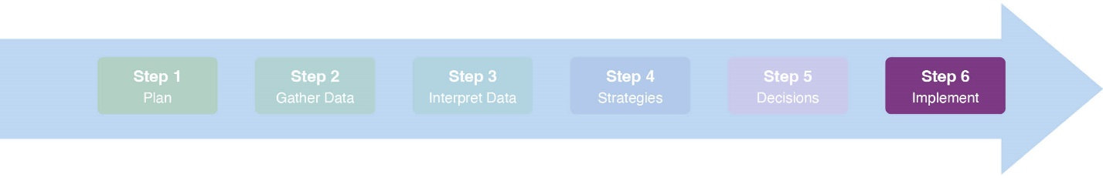Coalitions Lite Meeting #6: Approve & Implement the Strategic Plan |FACILITATOR GUIDE

## Time: *1 hour*

## **Objectives**

1. Review the Strategic Plan
2. Approve the Strategic Plan
3. Create an action plan to implement the Strategic Plan
4. Celebrate, wrap up, and next steps

## **Materials**

1. [Step 6 Standards](https://slco.org/globalassets/1-site-files/health/programs/community-groups/coalitions-lite/standards.xlsx)
2. Meeting #6 Facilitator Guide (this guide)
3. [Meeting #6 Power Point Presentation](https://slco.org/globalassets/1-site-files/health/programs/community-groups/coalitions-lite/step6powerpoint.pptx)
4. [Meeting #6 Meeting Minutes Template](https://slco.org/globalassets/1-site-files/health/programs/community-groups/coalitions-lite/step6minutes.docx)
5. [Meeting #6 Participant Agenda](https://slco.org/globalassets/1-site-files/health/programs/community-groups/coalitions-lite/step6agenda.docx)
6. The Final Strategic Plan (for reference during the meeting)
7. [Action Plan Tool](https://slco.org/globalassets/1-site-files/health/programs/community-groups/coalitions-lite/Step6ToolActionPlan.docx)

## **Facilitator Preparation**

☐ Review Coalitions Lite Meeting #6 Power Point presentation, including notes sections. Fill in any check-ins, timelines, priorities, etc.

☐ Review the Meeting #6 Facilitator Guide (this guide)

☐ Review the Meeting #6 Power Point presentation, including the notes section. Fill in any needed information in the slides.

☐ Decide on a *brief* team building activity or quick check-in

☐ Review the Strategic Plan and make any final edits

☐ Create any materials (handouts, etc.) to present the Strategic Plan. Be sure to print out copies of both the completed strategic plan and the action plan template, as well as emailing both documents out to participants in advance of the meeting.

☐ Decide the process for how the coalition will officially approve the Strategic Plan and update the Meeting #6 Power Point to reflect your voting method.

☐ Briefly review the Action Plan Tool.

## **General Notes about Meeting #6**

* This meeting may include a broader group of people, including the full coalition, specific key leaders, and/or important stakeholders. In thinking about who to invite, consider who will be implementing the strategies laid out in the Strategic Plan and who you will need support or approval from.
* This agenda assumes that attendees are already somewhat familiar with the prioritized issues, contributing factors, and strategies laid out in the Strategic Plan. If not,adjust the meeting agenda to include a deeper discussion of the plan.

**Agenda (Facilitator Version)**

### Welcome, introductions, and overview *(Slides 1-4)* (10 min)

* 1. If necessary, conduct introductions. Identify your role as facilitator.
  2. Conduct a brief team building “check-in.”
  3. Identify the notetaker(s) and timekeeper.
  4. Review the objectives for the meeting.

### Review and Approve the Strategic Plan *(Slides 5-10)* (15 min)

* 1. Quickly summarize the process the strategic planning workgroup went through to create the Strategic Plan (no more than 5 minutes).
  2. Review the Strategic Plan document.
  3. Vote on approval for the Strategic Plan.

### Draft an Action Plan to Implement the Strategic Plan *(Slides 11-13)* (30 min)

* 1. Create an action plan for each prioritized issue. For each strategy, lead a discussion.
  2. Have the notetaker record the final decisions in the Action Plan Tool.

### Wrap up and Next steps *(Slides 14-17)* (5 min)

1. Assignments
2. Lead a meeting check-out
3. Celebrate your progress!
   * You may want to schedule time to formally thank the people who worked on the Strategic Plan or to serve some food for celebration.
4. Wrap-up!