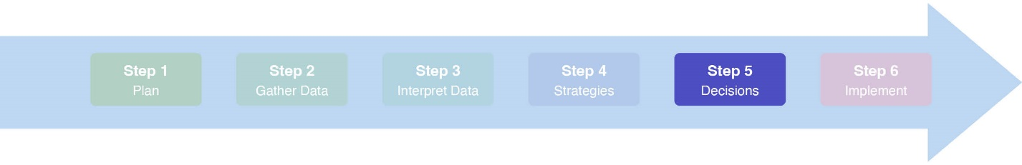Coalitions Lite Meeting #5: Finalize Decisions| Facilitator guide

## Time: *1 hour*

## **Objectives**

1. Set expectations for the meeting
2. Review workgroup’s progress on Coalitions Lite
3. Finalize the strategy selection
4. Review the Strategic Plan Template
5. Set a process for drafting the Strategic Plan
6. Wrap up and next steps

## **Materials**

1. [Step 5 Standards](https://slco.org/globalassets/1-site-files/health/programs/community-groups/coalitions-lite/standards.xlsx)
2. Meeting #5 Facilitator Guide (this guide)
3. [Meeting #5 Power Point Presentation](https://slco.org/globalassets/1-site-files/health/programs/community-groups/coalitions-lite/step5powerpoint.pptx)
4. [Meeting #5 Meeting Minutes Template](https://slco.org/globalassets/1-site-files/health/programs/community-groups/coalitions-lite/step5minutes.docx)
5. [Meeting #5 Participant Agenda](https://slco.org/globalassets/1-site-files/health/programs/community-groups/coalitions-lite/step5agenda.docx)
6. “Strategies” flip chart sheets from Meeting #4
7. [Selecting Strategies to Create Change](https://slco.org/globalassets/1-site-files/health/programs/community-groups/coalitions-lite/Step4SelectingStrategies.docx) Handout (for reference during the meeting if needed)
8. [Voting Techniques](https://slco.org/globalassets/1-site-files/health/programs/community-groups/coalitions-lite/AppendixAVoting.pdf) [information sheet](https://slco.org/globalassets/1-site-files/health/programs/community-groups/coalitions-lite/AppendixAVoting.pdf)
9. [Strategic Plan template](https://slco.org/globalassets/1-site-files/health/programs/community-groups/coalitions-lite/strategicplan.docx)

## **Facilitator Preparation**

☐ Review Coalitions Lite Step 5 Power Point, including the notes sections

☐ Review the Meeting #5 Facilitator Guide (this guide)

☐ Decide on a *brief* team building activity or quick check-in

☐ Make any adjustments to the meeting based on Meeting #4 check-out feedback

☐ Briefly review the Strategy Overview Tool updated in Meeting #4

☐ Briefly review the Strategic Plan Template

☐ Make copies of the Strategic Plan Template

**Agenda (Facilitator Version)**

### Welcome, Introductions, and Overview *(Slides 1-4)* (10 min)

* 1. If necessary, conduct introductions. Identify your role as facilitator.
  2. Conduct a brief team building “check in.”
  3. Identify the notetaker(s) and timekeeper.
  4. Review the process for taking and sharing notes and other documents.
  5. Review the objectives for the meeting.

### Review Progress on Coalitions Lite *(Slides 5-8)* (5 min)

* 1. Review where the workgroup is in the process.
  2. Summarize the outcome of Meeting #4.
  3. Review progress for any uncompleted action steps from previous meetings.

### Finalize our Strategy Selection *(Slides 9-11)* (15 min)

* 1. Review and address any feedback from stakeholders on the strategy list.
  2. Vote with Fist to Five on the final list.

### Create a Process for Drafting the Strategic Plan *(Slides 12-14)* (20 min)

* 1. Review the Strategic Plan template.
  2. Assign each section to a group member. The actual drafting of the plan will be done by various group members between Meetings #5 and #6.
  3. Assign at least two members of the workgroup to review the whole draft before submitting it to the larger coalition and other key stakeholders.
  4. Consider how and when the larger coalition or other stakeholders will receive the draft and how requested revisions will be addressed. This should happen prior to Meeting #6 when the full coalition will officially approve the plan. The bulk of Meeting #6 should be used for outlining the activities and steps to *implement* the Strategic Plan.

### Wrap up and Next steps *(Slides 15-19)* (10 min)

* 1. Review assignments.
  2. If not scheduled, schedule Meeting #6 (the final meeting!). **Meeting #6 includes the larger coalition and other key stakeholders** and should be scheduled with enough time for stakeholder review of the plan and for the workgroup to finalize revisions.
  3. Lead a meeting check-out.
  4. Celebrate your progress and wrap-up!