Coalitions Lite|Overview

Welcome to Coalitions Lite!

This document provides an overview of Coalitions Lite, a framework to guide your coalition through a strategic planning process. During this process, your coalition will use information from different sources to understand your community’s needs and identify strategies to meet those needs. By understanding your community’s needs – and using that information to set priorities – your coalition’s work will have a greater impact!
The strategic planning process outlined in Coalitions Lite is only one part of a coalition’s work. The figure below shows how Coalitions Lite (white boxes) fits into the larger coalition process.
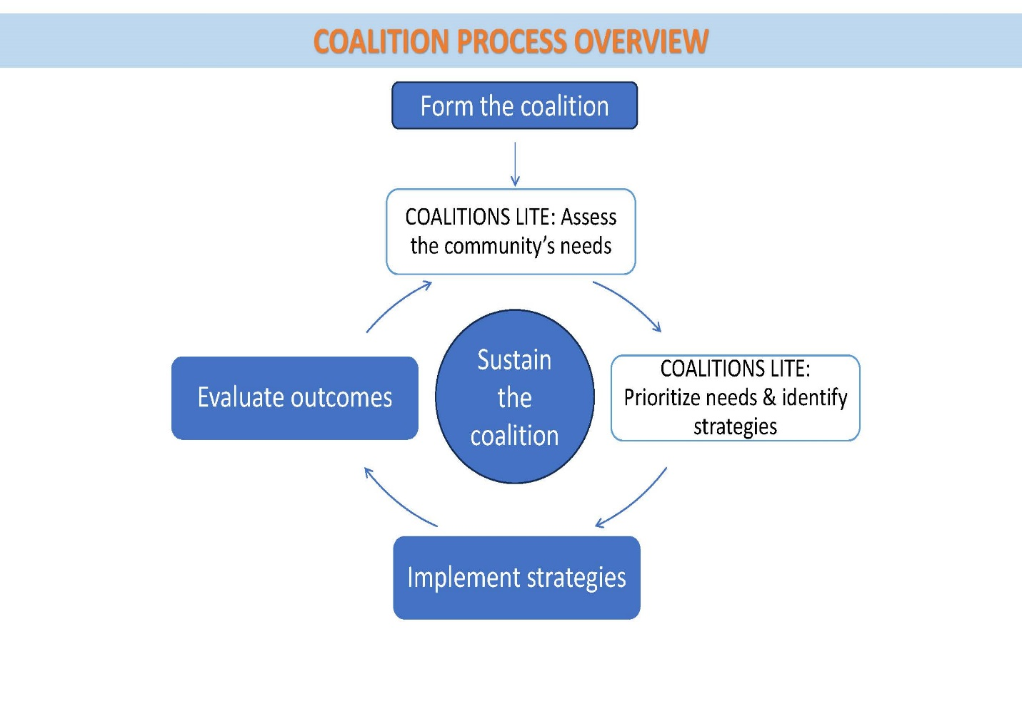

How long will Coalitions Lite take to complete?

The Planning Process Overview graphic reviews the six steps that make up Coalitions Lite. The recommended time for the whole strategic planning process is between 4 and 8 months. Most steps require a 1 to 3-hour meeting with the bulk of the work occurring during meetings. However, the meeting facilitator must prepare for each meeting and some Coalitions Lite steps have assignments between meetings. The time needed to accomplish tasks between meetings will vary depending on the task and the number of people helping but will likely take between 2 and 8 hours per person.

Coalitions Lite Steps
Step 1 Plan for Coalitions Lite
Step 2 Step 2a: Identify data needs & Step 2b: Conduct interviews & summarize data
Step 3 Interpret data & select priorities
Step 4 Review resources and identify strategies
Step 5 Finalize decisions and write the Strategic Plan
Step 6 Approve & implement the strategic plan
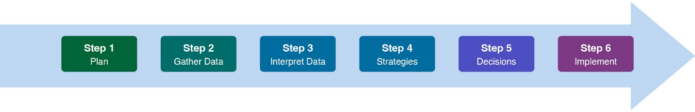

Overview of the Coalitions Lite Tools

Coalitions Lite provides these tools to help you:
- The Standards workbook helps keep you on track and ensure you accomplish each step.
- The Facilitator Guides help the person running the meeting understand how to best lead the group through joint decision-making to achieve objectives.
- The Power Point presentations are your roadmap to working through each meeting.
- You have an agenda template and a minutes template for each meeting.
- A template has been provided for the Coalitions Lite Plan created in Step 1, for the Strategic Plan itself created in Step 5, and for the Action Plan created in Step 6.
- There are also several tools and forms to help you during Step 2b.
In addition, information sheets provide general guidance to working in coalitions, such as:
- how to make decisions as a group
- how to build strong teams
- considerations for inclusion and diversity
- other external resources about coalition work
Supporting Tools
Meeting support | Facilitator Guides  Power Point Presentations
 | Agenda templates
 | Minutes templates
Start Here | Coalitions Lite Overview (this document)  Coalitions Lite Standards
Step 1 | Coalitions Lite Plan Template
Step 2 | Step 2 Data Source Overview  Step 2 Data Tips  Step 2 Issue Overview  Step 2 Interview Checklist  Step 2 Interview Form with Data Summary Tool  Step 2 Data Summary Tool Example
Step 3 | None
Step 4 | Selecting Strategies to Create Change Information Sheet
Step 5 | Strategic Plan Template
Step 6 | Action Plan Template
Appendix A  General Process Support | Coalitions Lite Process Overview – Example
 | Coalitions Lite Process Overview – Editable
Diversity in Community Coalitions
Tips and Tricks for Meeting Facilitation
Coalition Roles in Strategic Planning
Coalition Team Building
Voting Techniques
Appendix B | University of Kansas Community Toolbox
Additional Resources | Center for Communities that Care  Community Anti-Drug Coalition Handbook & Primers  Atlas of Public Management (vision to action plan connection)  Prevention Technology Transfer Center Network  Utah Prevention Coalition Association

What coalition work is NOT included in Coalitions Lite?

Forming the coalition: Before you start, the coalition needs to have a stable and engaged group of coalition members and community leaders with a common understanding of how coalitions operate. If you do not have a core group that has done this foundational work, consider implementing the Coalitions Formation step for bringing people together and forming a team. It is better to build a solid foundation first – even if it takes longer – than to start the Coalitions Lite process before the coalition is ready and risk stalling midstream. Engaging in strategic planning is time consuming – You want to make sure your coalition is set up to succeed!
Resources:
- Coalitions Formation Step
- Communities That Care: Tools for Community Leaders
- CADCA Coalition Handbook

Implementing strategies: Once you have selected evidence-based strategies that impact your selected priorities through Coalitions Lite, it will be time to implement those strategies! Some strategies are fairly straightforward, but others require knowledge and skills to implement well. You want to be sure you are implementing with “fidelity,” meaning, you are doing the work in the way it was intended.
Resources:
- CADCA Implementation Primer: Putting Your Plan into Action
- National Implementation Research Network – Resource Page
- Community Toolbox – Chapters 20-26

Evaluating outcomes: It’s important for coalitions to understand whether their strategies are having an impact. Even simple evaluation tools can offer coalitions a basic understanding of how well they’re doing.
Resources:

CADCA Evaluation Primer: Setting the Context for a Community Coalition Evaluation

Community Toolbox: A Framework for Program Evaluation

Coalition sustainability and management: From the coalition’s first steps through all its activities and transformations, the coalition must always pay close attention to managing the internal workings and sustainability of the coalition, such as:
- Coalition member recruitment
- Coalition member engagement and training
- Community representation on the coalition (diversity)
- Funding and sustainability
- And other ongoing topics
Resources:

CADCA Capacity Primer: Building Membership, Structure and Leadership
- CADCA Cultural Competence Primer: Incorporating Cultural Competence into Your Comprehensive Plan
- Community Toolbox: Enhancing Cultural Competence
- CADCA Sustainability Primer: Fostering Long-Term Change to Create Drug-Free Communities

Let’s go!

