### Name ________________________________

### Matter is made of atoms

Matter is made up of tiny particles called atoms. There are over 100 different types of atoms. Examples of atoms are hydrogen, carbon, nitrogen, oxygen, iron and silicon. Two or more atoms bound together is called a molecule. Examples of simple molecules include water (H2O), atmospheric oxygen (O2), and carbon dioxide (CO2). Most atoms and molecules attract each other when they are a small distance apart. However, they repel when they get very close together.

There are four states of matter, solid, liquid, gas and plasma. (While plasma is the most common state of matter in the Universe, it is not a common state of matter on Earth).

In a solid, the atoms or molecules are arranged in some kind of pattern. For example, in ice, the water molecules form a six-sided pattern surrounding regions of empty space.

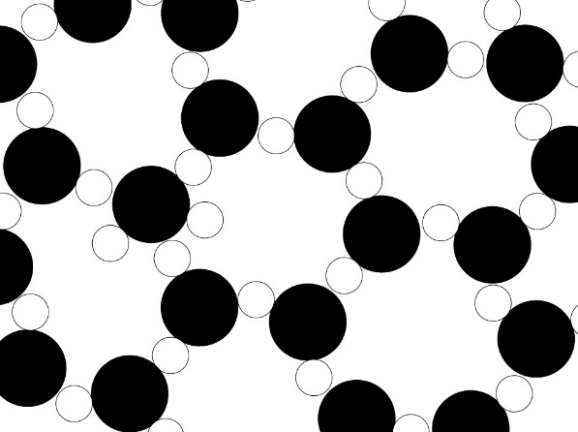*A model of ice magnified one billion times*

The circles represent atoms of oxygen (black) and hydrogen (white). Note the empty spaces within the ice structure. This is the reason solid water (ice) is less dense than liquid water. For most substances, the solid form has greater density than the liquid form.

This model is inaccurate in several ways. In this model the atoms are drawn with sharp edges in a two-dimensional arrangement. In reality, atoms do not have a sharp edge and the actual structure of ice is three dimensional. The model is also inaccurate in that real atoms and molecules are always moving.

In a solid, each atom or molecule is held in its place by electric forces. While the atoms cannot move around, they are not standing still. They are shaking or vibrating in place. Temperature is the measure of the average motion of the atoms or molecules. As the temperature of an object increases, the vibrations of its atoms will increase. When the temperature is high enough, atoms will vibrate fast enough to break out of their places. This is called *melting*. While the melting point of water is 32 °F (0 °C), the melting point of iron is 2800 °F (1538 °C). ​This is because the electric forces between iron atoms are much stronger than between water molecules.

In a liquid, even though the atoms or molecules are still attracted to each other, they can move around. As they move, they are continually vibrating and bouncing, twisting and colliding with each other. If we transfer energy into the liquid by heating it, the motion of the molecules will increase. As they move faster and faster, collisions between molecules will occur more often and with greater force. This causes the molecules to move farther apart from each other. So, the same number of molecules will take up more space, or occupy a greater volume.

*The density of a substance is its mass per unit volume (density = mass/volume). Use computational thinking to figure out what happens to the density of a liquid when it is heated.*

If heating continues, the speed of the molecules will increase. When a molecule is moving fast enough, it can escape the force of attraction between molecules and fly away. As molecules gain energy and fly apart, they become separated from one another and turn into a gas. This process is called *evaporation.*

In a gas, the atoms and molecules are very far apart from each other. However, they are moving very fast and constantly colliding with each other. If a gas is heated, the same thing happens that happens in a liquid. Collisions between molecules occur more often with greater force. This causes the molecules to expand into a larger space. So, the same numbers of molecules occupy a larger volume.

*Use computational thinking to figure out what happens to the density of a gas when it is heated.*

Electrons are small particles that occupy the outer regions of an atom. If a gas is VERY hot, the atoms or molecules move VERY fast. When they collide, the force is strong enough to knock electrons out of the atoms or molecules. This results in the fourth state of matter, plasma. Plasma is a mixture of negatively charged electrons and positively charged atoms or molecules. Due to its higher temperatures, a plasma will occupy more volume than a gas with equal mass. Plasma exists in an upper layer of Earth’s atmosphere called the *ionosphere*. Plasma also forms inside fluorescent light bulbs, in part of a candle’s flame, and in stars.

Questions:

1. When a liquid or gas is heated what property changes?

mass volume mass and volume (circle one)

1. What happens to the density of a liquid when it is heated?
2. What happens to the density of a gas when it is heated?
3. Order the states of matter from least dense to most dense

Low Density ___________ ____________ ____________ ______________ High Density

**KEY**

Questions:

1. When a liquid or gas is heated what property changes?

mass volume mass and volume (circle one)

1. What happens to the density of a liquid when it is heated?

Density will decrease

1. What happens to the density of a gas when it is heated?

Density will decrease

1. Order the states of matter from least dense to most dense

Low Density __Plasma___ ____Gas_____ ___Liquid___ ___Solid______ High Density