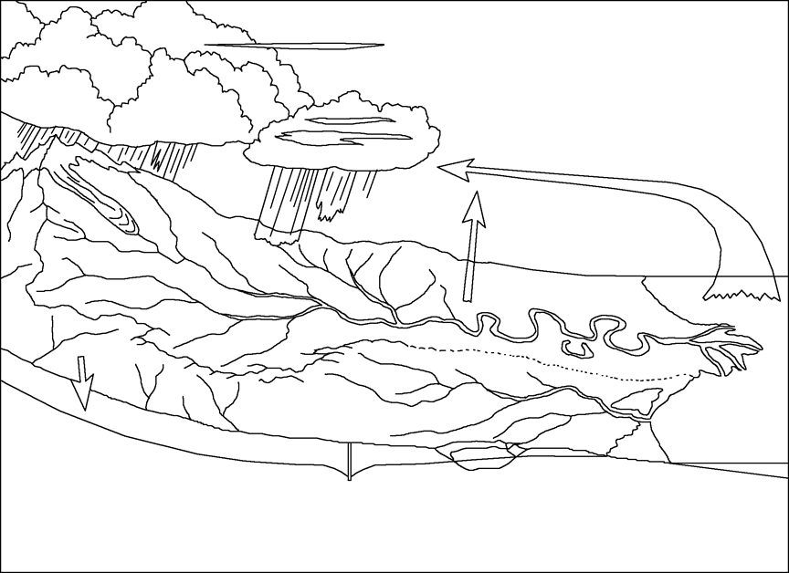

**Instructions:**

1. As you watch the video, look for the movement of water (either as a liquid or a gas). Try to figure out where water is changing from a liquid to a gas and where water is changing from a gas to a liquid.
2. On the worksheet diagram, in every place where water is moving, write a brief description explaining how or why the water is moving. Where water is changing from a gas to a liquid or a liquid to a gas, include that in your description.

**Questions:**

1. What is the role of the Sun in the movement of water in this system?
2. What is the role of density and/or gravity in each part of the cycle where water is moving?



Winds move clouds

Liquid water falls to the ground

Snow falls to the ground

Heated air and gaseous water rises

Liquid water moves underground towards the ocean

Water absorbs energy from the Sun and changes from liquid to gas

Water changes from gas to liquid and forms clouds

Liquid water flows downhill to the ocean

Liquid water moves into the ground

KEY

**Instructions:**

1. As you watch the video, look for the movement of water (either as a liquid or a gas). Try to figure out where water is changing from a liquid to a gas and where water is changing from a gas to a liquid.

2. On the worksheet diagram, in every place where water is moving, write a brief description explaining how or why the water is moving. Where water is changing from a gas to a liquid or a liquid to a gas, include that in your description.

**Questions:**

1. What is the role of the Sun in the movement of water in this system?

The Sun provides the energy to change liquid water into a gas and to heat the gaseous water (and air) causing it to rise.

2. What is the role of density and/or gravity in each part of the cycle where water is moving?

Air/gaseous water heated by the Sun has a lower density than surrounding air, so it rises. Gravity causes liquid water (and snow) to fall from the clouds to the ground. Gravity pulls liquid water down into to the ground and along the surface of the ground from higher to lower elevation until it moves back into the ocean (or lake).